Nepal College of Information Technology
Unit Test
Fall 2011
Program : BE ELX/CE Time : 2 hrs
Semester : Fall (III) FM : 70
Subject : Network Theory PM : 35

- Candidates are requested to give their answer as far as practicable in their own words.
- The figure in the margin indicates the full marks
- Attempt ALL question
1. a) In the given network, the switch is changed from position 1 to position 2 at t=0, steady state condition having reached previously. Find the values of i, 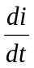, 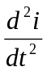 at t=0. 7
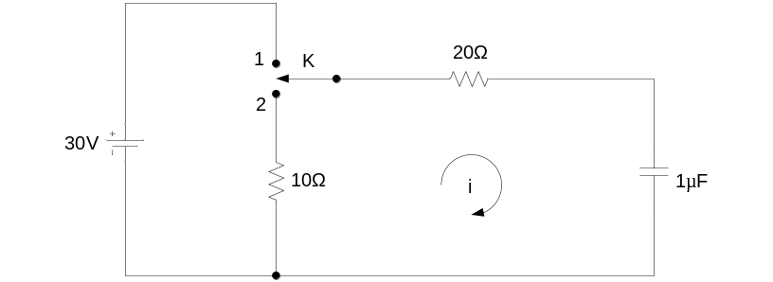
b) In the given circuit, switch K is opened at t=0. Find the values of v₁, v₂, 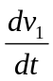 and 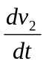 at time t=0. [8]
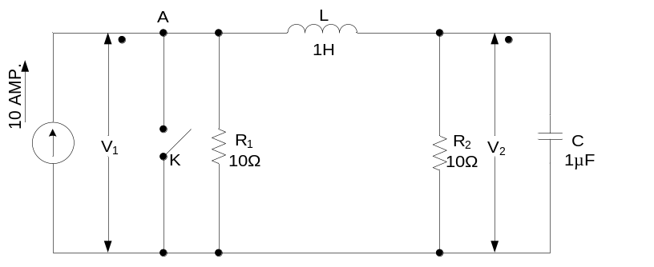
2. a) In the given circuit, switch K is closed at time t=0, the steady state condition having reached previously. Obtain expression for the current in the circuit at any time t. If R₁=R₂=100 ohms, V=10V and L=1H, calculate at time t=5milliseconds, (i) current i (ii) voltage drop across R₂ and (iii) voltage across L. 8
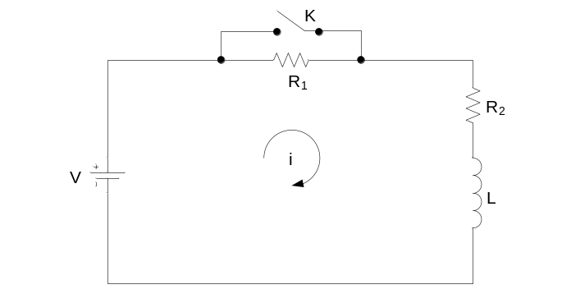
b) In the given network, the switch is opened at t=0. Solve for the values of v(t) if I=10 amp, R = 1000Ω and C = 1µF. 7
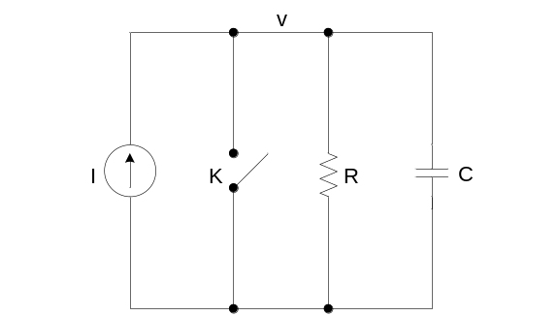
3. a) In the series RLC network, V₀=5 volts, L = 1H , R = 4Ω and C=0.2 farad. Switch is closed at t=0. It is required to obtain the particular solution for i(t). 7
b) Find the general solution of the following non homogeneous equation:
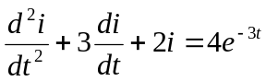 subjected to initial conditions i(0)=1 and 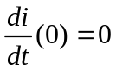. 8
4. a) A sinusoidal voltage v(t) = 4sin (10⁶t+π/4) is suddenly applied at time t=0 to a series RL circuit comprising of resistor R=1Ω and inductor L=1mH. Obtain the total particular solution for the current i(t) through the circuit. Assume zero initial current through the inductor before switching. 8
b) An exponential voltage v(t) = 10e^{-2t} is supplied at time t=0 to a series RC circuit comprising of resistor R=2Ω and capacitor C= 0.1 farad. Obtain the particular solution for current i(t) through the circuit. Assume zero initial charge across the capacitor. 7
5. Write short notes on any two of the following: 2*5=10
a) Time constant of RC circuit
b) Damping ratio
c) Initial Conditions

